> W:=1+2*sqrt(p/Pi)*exp(-p)-erf(sqrt(p));
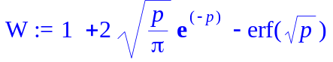
>
> simplify(diff(W,p));
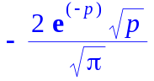
>
> simplify(diff(W,p$2));




